Dear Auth Students,
Now 2022 SWUFE "Chinese Bridge" Delegation Online Program is relaunched for you in March! Thanks for your continuous supporting! You may learn Chinese courses online, experience Chinese culture and Chinese life for FREE during this program. We sincerely invite you to join us!. Since this program has quota of participants, it will base on the principle of “First Come, First Served”. You may also contact the program coordinator via zhuangdian@swufe.edu.cn
Introduction
This program period is during Mar.14, 2022 ~ Mar. 25, 2022(2 weeks). In this program, a series of language courses and cultural activities will be presented online. We will take "live streaming classes + online activities + video courses+ online tutoring" as the online learning method. The opening ceremony and farewell ceremony will be also provided. We’ll arrange the class time reasonably to avoid time differences. The timetable will be released soon after your registration.
Program Features
SWUFE “Chinese Bridge” Delegation Online Program is unfolded here, in Chengdu, one of China's most well-being cities. In this program, you will learn real-time language courses based on your Chinese level, such as General Chinese and Business Chinese; you may also experience the below sites of Chengdu through our camera lens: wearing Chinese traditional costumes to visit the former residence of a famous Chinese ancient poet -Du Fu's Thatched Cottage; a trip of Chengdu- Ancient Shu, Breath of Life and Sense of Modern to experience two sides of Chengdu-modern urbanism and historical weight. Video courses such as visiting Chengdu Panda Base and DIY Sichuan cuisine will also be presented. There are more surprises awaiting you!
Application
This program is free charge and application deadline is set on March 13, 2022. All non-Chinese citizens are qualified for this program. Please click the link: https://www.wjx.top/vj/mRVRSgg.aspx or scan the attached QR code for online application. The whole application procedures only cost you about 5 minutes.
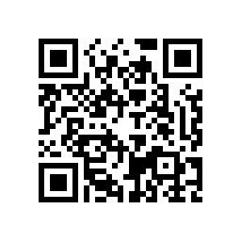
Certificate of Completion
For students who complete this program, we will send you the Certificate of Completion of this program.
Contact
zhuangdian@swufe.edu.cn
+86-28-87355437
Thanks for your supporting and cooperating! We wish you a happy Chinese new year of tiger! Hope to have a virtual meet soon!

Warm regards,
College of International Education
Southwestern University of Finance and Economics
55 Guanghuacun Street
Chengdu 610074
China
Tel/Fax: (+86) 28 8735 5437
Website: http://international.swufe.edu.cn/

